

**CZ3005 Artificial Intelligence**

**Lab Assignment 3: Subway Interactor**

***Kumar Mehul (1822146E)***

***AY 20/21 Semester 2***

**Lab Group: TS8**

**School of Computer Science and Engineering (SCSE)**

**Objective**

This assignment solves the third question ‘Subway Sandwich Interactor’ by using a Prolog script which offers different meal options for the user, and then goes on to recommend breads, mains, veggies, sauces, topups, sides and drinks. The recommendations are based on the previous selections, like there are no meat options for a veggie meal and there are no unhealthy sauces and drinks for a healthy meal. Other constraints are listed in more detail in the following sections.

**Implementation**

The user can interact with the Prolog script using a Telegram Bot which was developed using the ‘pyswip’ library of Python.

Instructions for Setting up

*Prerequisites*

1. Python 3
2. SWI-Prolog
3. Pip
4. Telegram Desktop/Mobile

*Running the Program*



The telegram bot can be accessed at *@subway_mehul_ai_bot* on Telegram Desktop/Mobile.

|  |  |  |
| --- | --- | --- |
|  |  |  |

**Walkthrough**

This section explains the key features of the Subway Interactor through examples.

Firstly, let’s take a look at the Prolog code.

|  |  |
| --- | --- |
| **Method for Appending Elements into a single list & Empty List Definition** | **Facts for Meal Type** |

**All Possible Elements in Each Category**

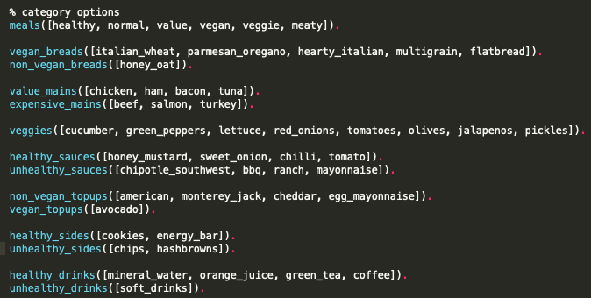

|  |  |
| --- | --- |
| **Aggregators to get all, available and selected options in each category** | **Appending main categories with subcategories** |

**Derive all available options for each category**

|  |  |
| --- | --- |
| **Breads** | No Honey Oat in Vegan Meals |
| **Mains** | No expensive mains (beef, salmon, turkey) in value meals  No main options in veggie and vegan meals |
| **Veggies** | No veggie options in meaty meal |
| **Sauces** | No unhealthy sauces (chipotle southwest, BBQ, ranch, mayonnaise) in healthy meal |
| **Topups** | No topups options in value meals  Only vegan topups (avocado) in vegan meal |
| **Sides** | No unhealthy sides (chips, hash brown) in healthy meals |
| **Drinks** | No unhealthy drinks (soft drinks) in healthy meals |

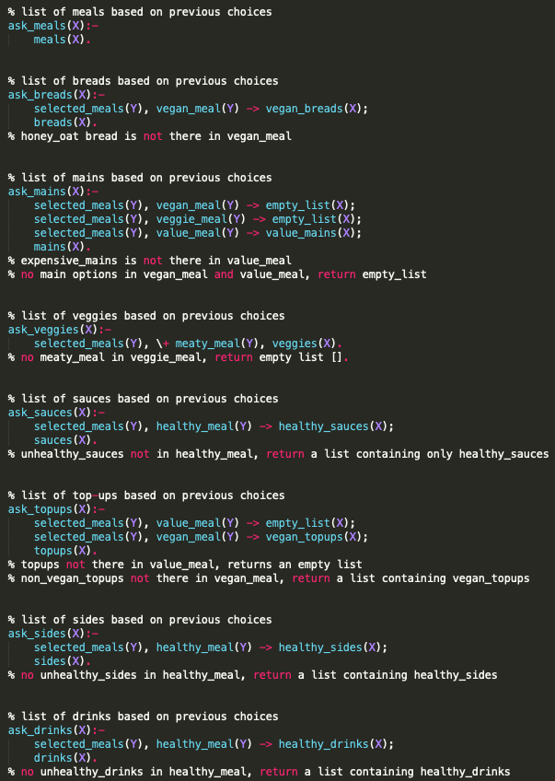

The ‘prolog_converter.py’ imports this prolog script and retrieves the options querying the script using the pyswip library.

**Flow of the Interactions**

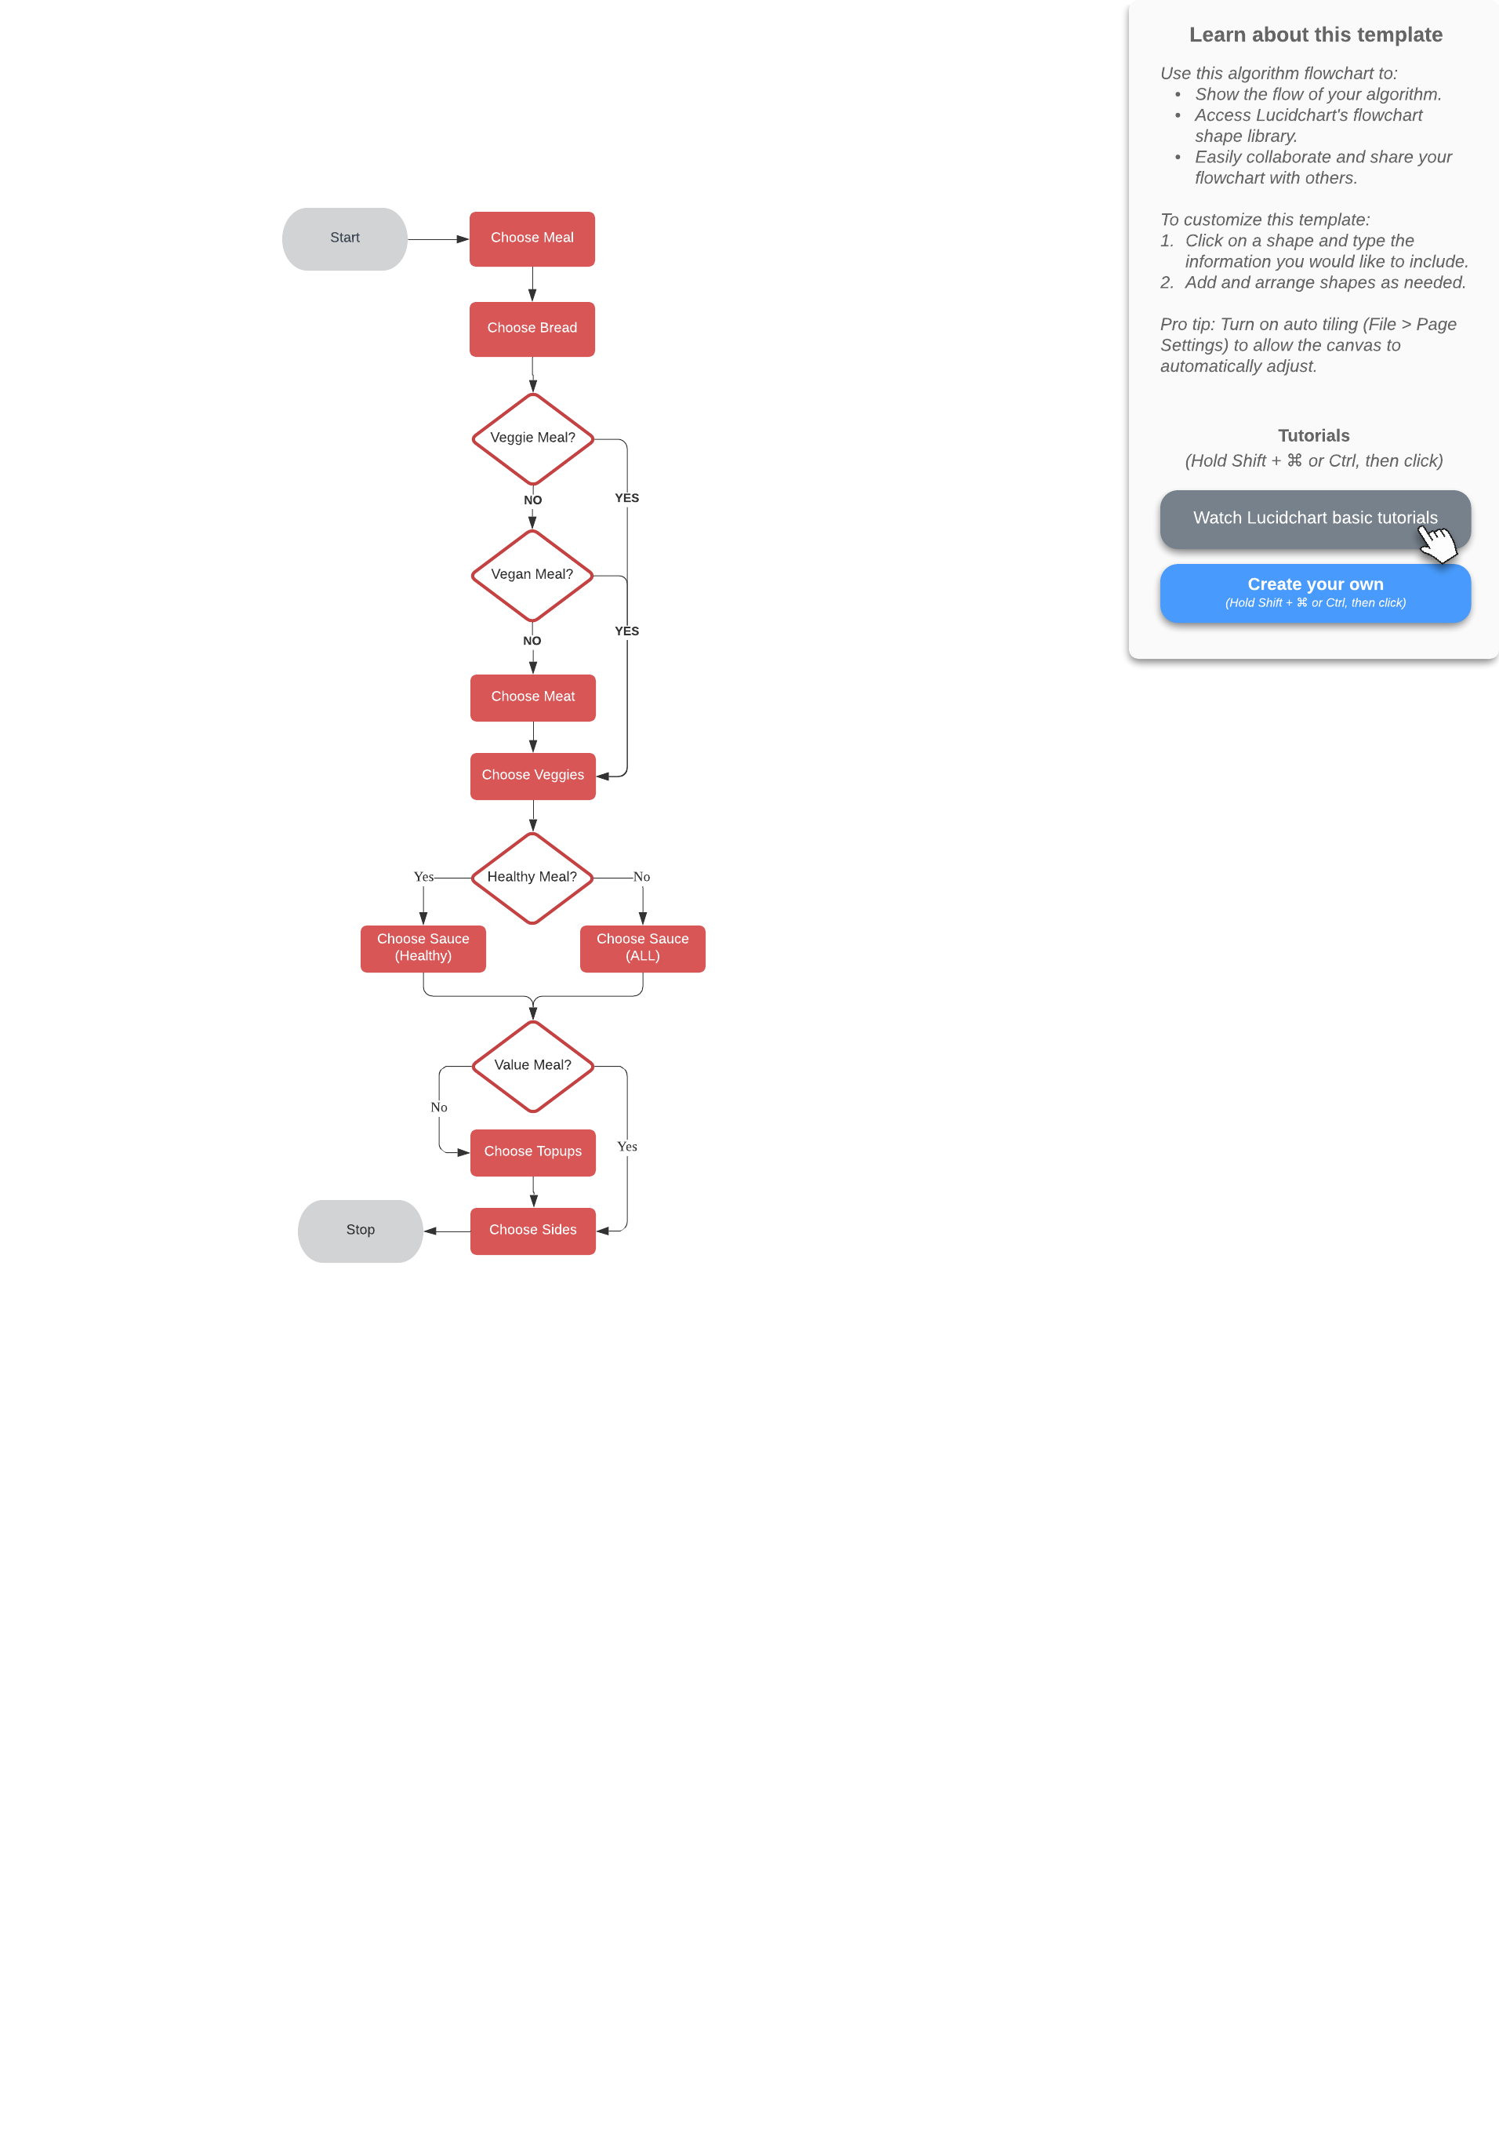

**Screenshots for each meal-type case**

**Value**

No Expensive Mains (Beef, Salmon, Turkey)

No Topups

|  |  |  |
| --- | --- | --- |
|  |  |  |
|  |  |  |

**Healthy**

No Unhealthy Sauces (Chipotle Southwest, BBQ, Ranch, Mayonnaise)

No Unhealthy Sides (Chips, Hash Brown)

No Unhealthy Drinks (Soft Drinks)

|  |  |
| --- | --- |
|  |  |
|  |  |

**Veggie**

No Main Options

|  |  |
| --- | --- |
|  |  |
|  |  |

**Vegan**

No Main Options

Only Vegan Topups (Avocado)

|  |  |
| --- | --- |
|  |  |
|  |  |

**Meaty**

No Veggie Options

|  |  |
| --- | --- |
|  |  |
|  |  |